FSAD SKILL-IN-SEM-EXAM
2400032797

1.ExamApplication.java:
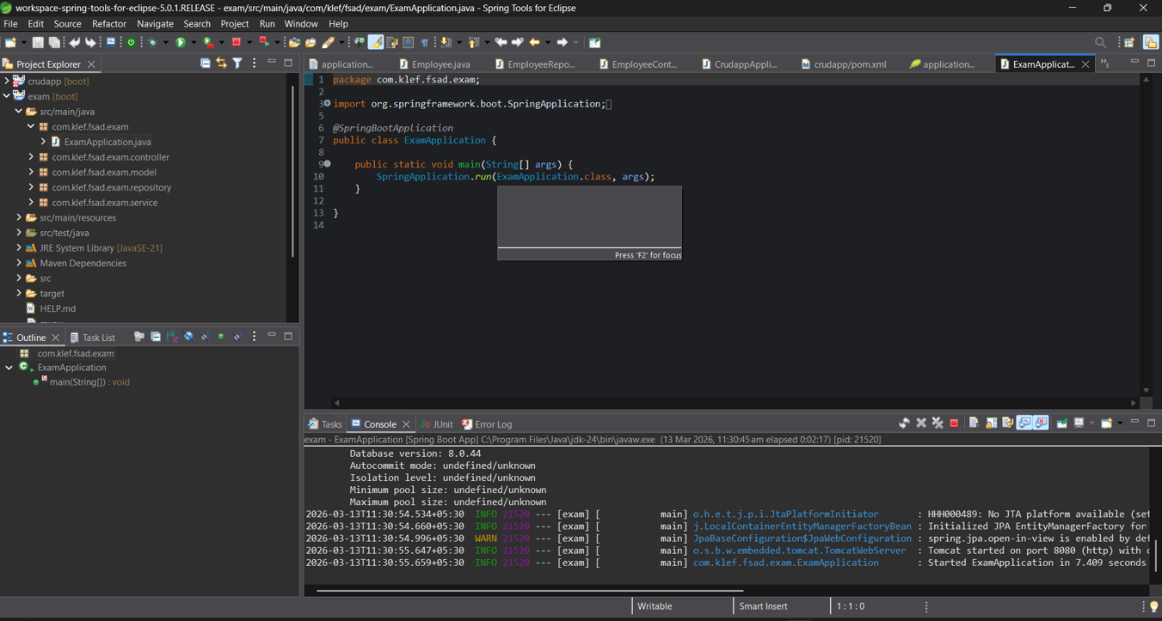

2.In postman: (PUT)
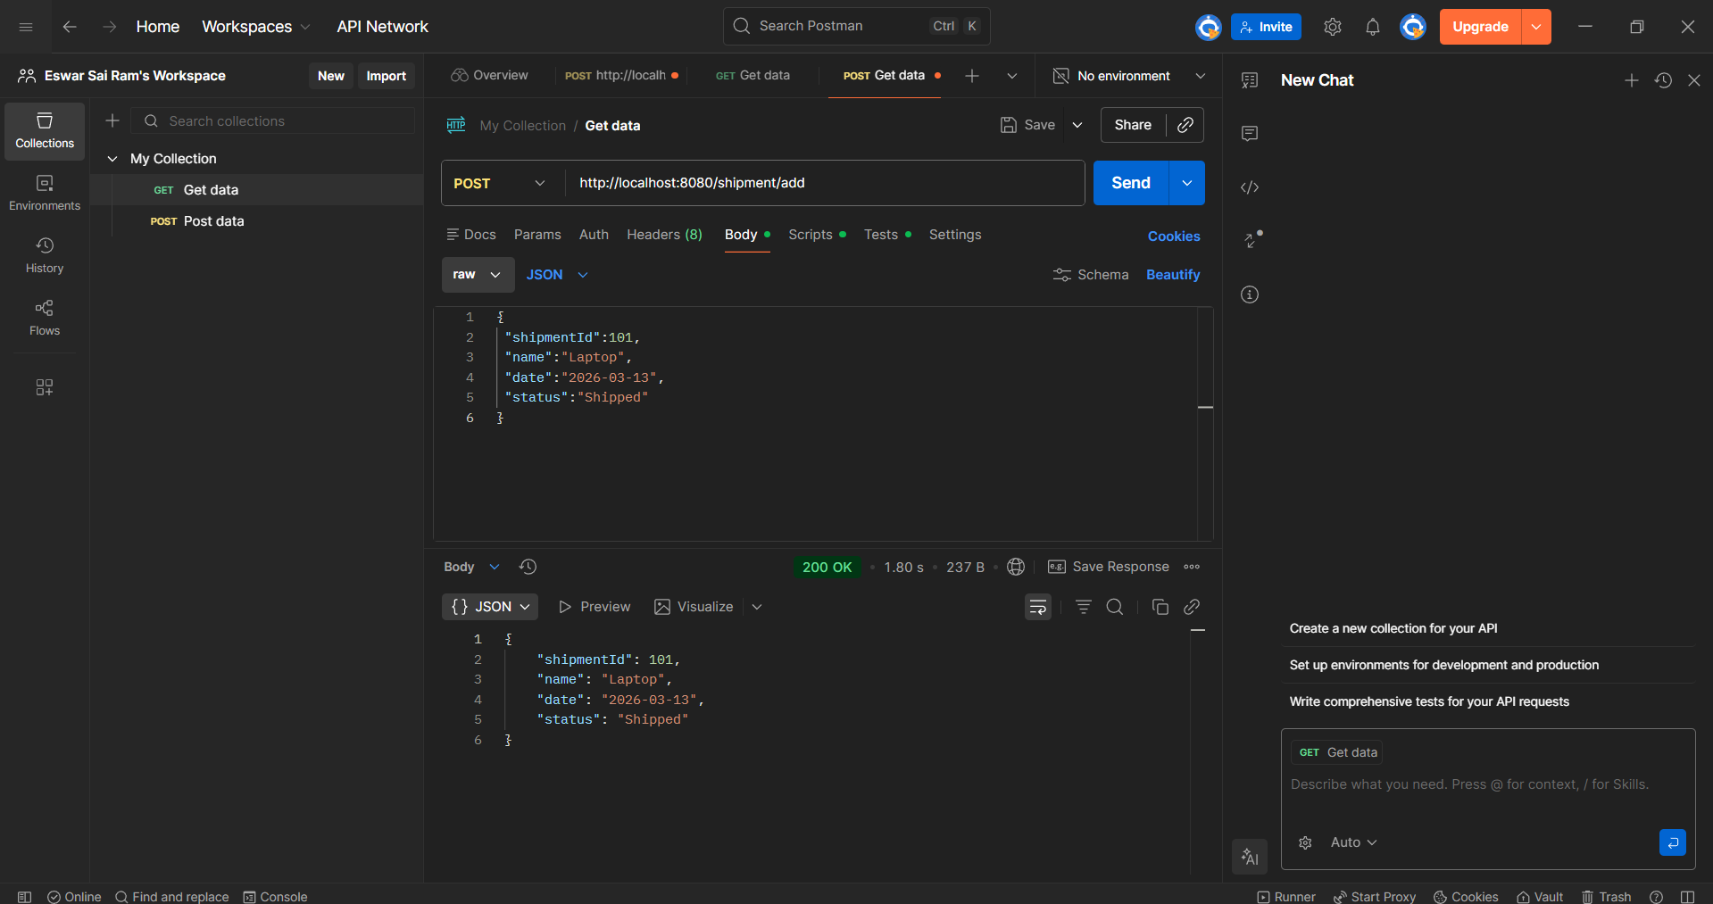
Post request success, Showing 200 OK

2.PUT REQUEST IN POSTMAN:
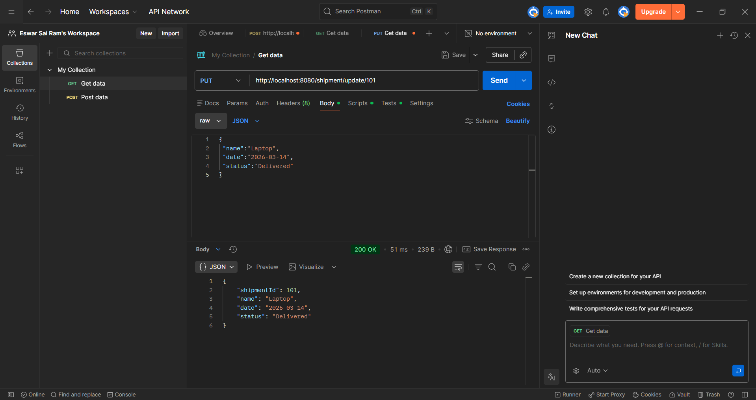
PUT REQUEST Success, SHOWING 200 OK

3.CREATING A DATABASE:
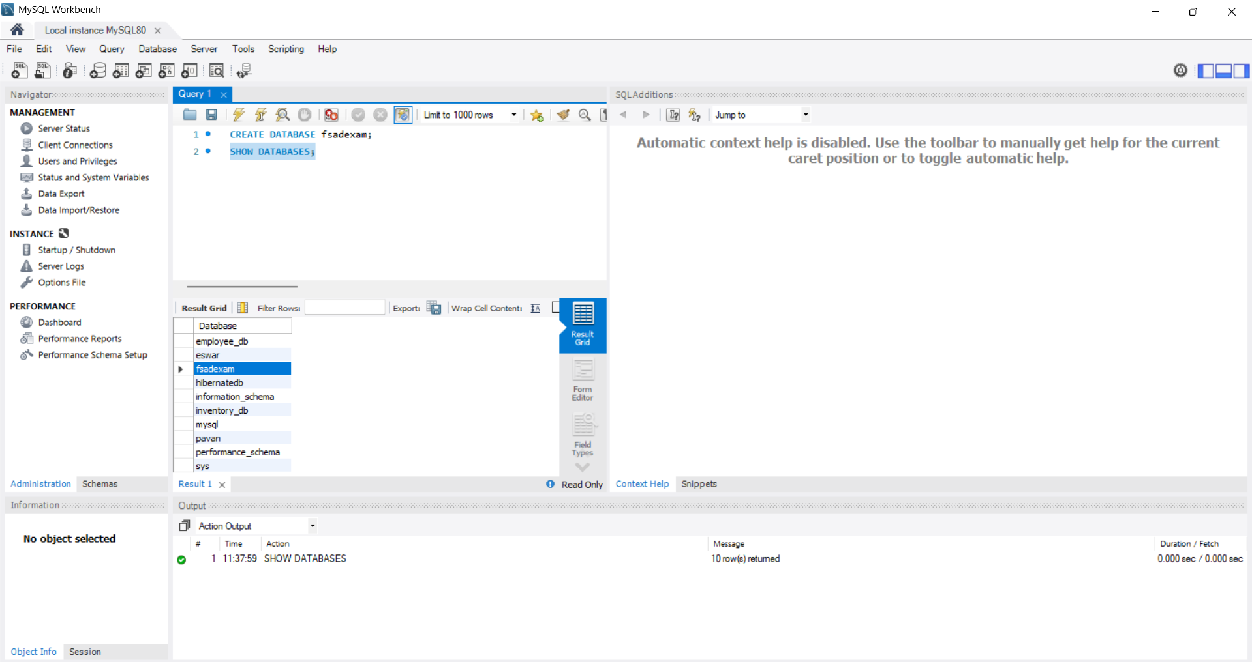
AS given in question DATABSE named FSAD is created.

